## **Setting up the Prestashop Agile CRM Module**

(Agile is compatible with Prestashop 1.7 or the later versions only)

### **1. How to Add the Agile Prestashop module to Prestashop**

## Download the Prestashop Agie CRM extension. Login to your Prestashop admin area. Go to Modules tab in admin panel and upload the downloaded zip file by clicking an Upload a Module button.

## 

### **2. Install the Agile CRM Prestashop Module**

Click on select file after clicking upload a module button.

Find the Agile CRM Module zip file from the explorer and upload it.

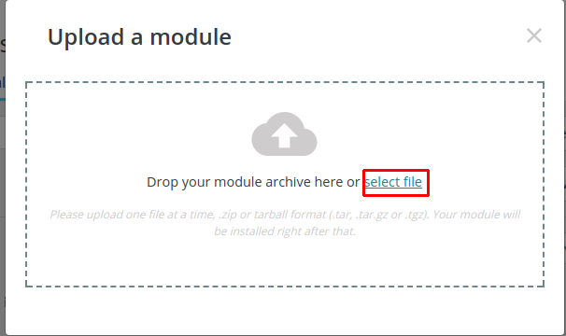

### **3. Manage Agile Prestashop Module**

### You can now find the "Configure" option for the Agile CRM Module.

Click on it and wait for the Agile CRM page to load completely.

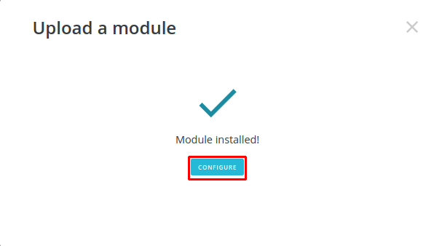

### **4. Enter Domain Name, Email and API key**

Sign up for a Agile CRM account if you don't already have one. Setup your account through this page.

Once you have an Agile CRM account, enter your Agile domain name, Email, Rest API key in the fields shown. (For API key, go to Admin Settings-->API & Analytics-->Rest API Key.)

Click on Save. If the message shown is Settings updated move down to Sync settings.

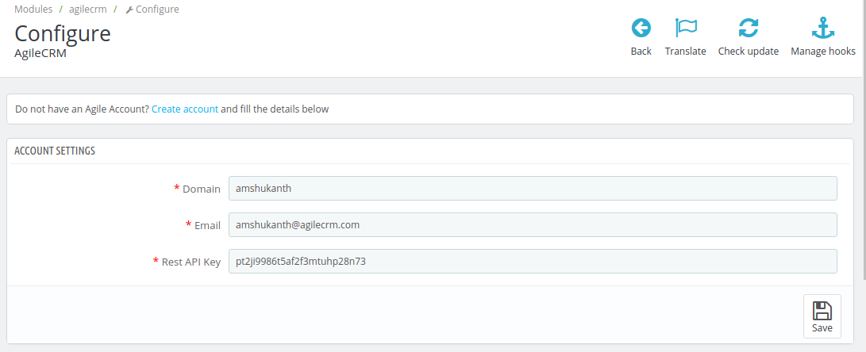

### **5. Settings**

In the Settings, enable all the three fields shown (or as per your requirement) and save the changes. That's it! You can now setup campaigns/ web-forms/ web-rules in Agile for smart user management, web-to-lead conversions and customer engagement.

